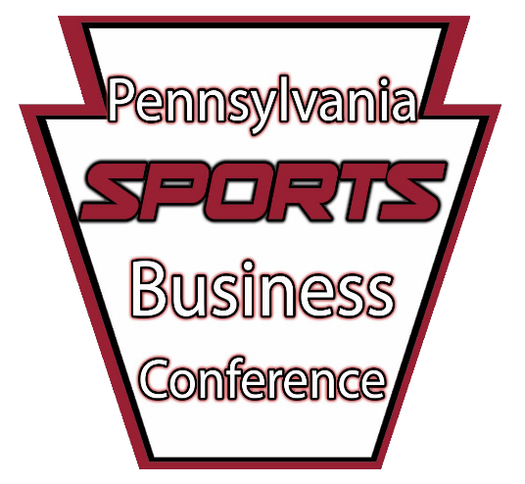
April 12th, 2024

Indiana University of Pennsylvania

Hadley Union Building (HUB)

Indiana, PA

Sponsoring the 2024
Pennsylvania Sports Business Conference

- Excellent opportunity to reach student populations from around Pennsylvania
- Increase brand awareness around campus and the community
- Develop a relationship with Indiana University of Pennsylvania
- Recognition as a supporter of the school
- Networking opportunities with sports teams, and businesses from the area
- Opportunity to showcase products and services

Sports Business Conference History

The Pennsylvania Sports Business Conference was first held in 2010. In years past, we have brought in hundreds of students and professionals from across the state, and we are looking to increase those numbers this year. The conference allows students to network with the professionals who attend the event as a guest, or as a speaker. In order to make this possible, we look for community support from our local businesses. We appreciate your consideration for our event.

Pennsylvania Sports Business Conference
225 Zink Hall Indiana, PA 15705

Email:
Aidan Sadoski at sgsy@iup.edu

SPONSORSHIP FORM

Name of Business

Street Address City State Zip
Phone Number Email Address

Check the sponsorship package your business is interested in:

Standard packages: Exclusive Packages:

Crimson Package $300 Exhibit Table $400
Gray Package $225 Sponsor a Speaker $600+
Black Package $150 Other:
White Package $75 Donation Amount (Please Specify)
TOTAL COST
(All checks can be made payable to the IUP Sports Business Conference)
225 Zink Hall Indiana, PA 15705

Sponsorship Packages
Standard packages

Crimson Package $300
- 9 sq. ft. banner with your logo displayed at the event
- Logo and link to business on website
- Includes all Gray Package benefits

Gray Package $225
- Featured in Sponsor Slideshow shown between sessions
- Full page advertisement in the event program
- Mentioned in two (2) breakout rooms
- Featured on conference webpage

Black Package $150
- Half page advertisement in the event program
- Mentioned in two (2) breakout rooms
- Featured on conference webpage

White Package $75
- Quarter page advertisement in the event program
- Mentioned in one (1) breakout room
- Featured on conference webpage
*For more information/explanations on Standard and Exclusive Packages, please contact Aidan Sadoski (contact information is provided on page 1).

Exclusive packages

Exhibit Table $400
  - On-side exhibition table in the lobby at the event to be used for data gathering or promotional purposes
  - Includes all Crimson Package benefits

Sponsor a Speaker $600+
  - Business may choose to sponsor one of our conference speakers
  - Business will be recognized as the official sponsor of one of our speakers on the conference itinerary, program and webpage
  - Promotional Video
  - Postings on conference social media
  - Includes all Crimson Package benefits

