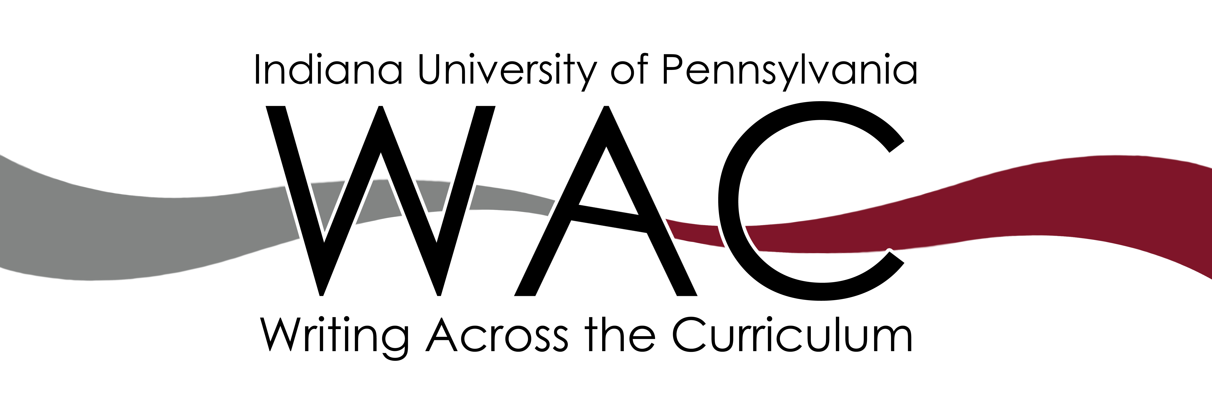
DEPARTMENT OF
NAME

Department Writing Plan

Compiled by
Professor, Department
Professor, Department
Bryna Siegel Finer, Director, Writing Across the Curriculum

Submitted to:
Professor, Department Chair
the Faculty of the Department
Dean, College
Provost Timothy Moerland

Table of Contents

Summary 3
Professional and Academic Genres In Food and Nutrition 4
Student Writing Skills and Abilities 4
Integration of Writing into Undergraduate Curriculum 5
Communicating Writing Expectations to Students 5
Implementation and Assessment of Department Writing Plan 6
Writing Outcomes Curriculum Map 7
Appendix A -- Survey of FDNT Seniors 16
Appendix B – Results of Senior Survey, Spring 2016 25

Summary

Conception of plan (decision to meet with Bryna)

In creating their writing-enriched curriculum, two DEPT faculty, names, served as liaisons between WAC and DEPT. They used a template borrowed from the University of Minnesota and adapted by Siegel Finer to thoroughly investigate where and how writing was already being taught in the DEPT curriculum, and where and how writing could be added to the curriculum, in order to draft the DWP for their department instructors.

Descriptions of meetings, process, timeline. They also developed a statement of “Department Commitment to Writing” to include on all syllabi for courses that will be a part of the writing-enriched curriculum.

At a meeting on DATE, ##% of the DEPT faculty voted to support the Department Writing Plan as described below in addition to the WAC Director’s recommendations for continuing program facilitation on page ## of this document.

DEPT
Department Writing Plan
Rollout SEMESTER

Professional and Academic Genres In DISCIPLINE

Professionals in DISCIPLINE must have ……. The IUP Department of DEPT is committed to helping students in improving their writing skills toward the goal of being able to communicate as professionals in the field are required to do.

Student Writing Skills and Abilities

Students in DEPT need a variety of writing skills and abilities upon completion of their degree. These include:

The IUP Department of DEPT is committed to introducing, emphasizing, and reinforcing these skills and abilities throughout the curriculum, and does so through the purposeful mapping of writing assignments and activities that follows at the end of this document.

Integration of Writing into Undergraduate Curriculum

Department faculty have participated in professional development training in writing-to-learn pedagogy through writing workshops with the WAC director, participation in the end-of-year Liberal Studies writing workshop, and in full department faculty meetings that the WAC director has visited.

Writing instruction in DEPT is integrated in these two ways:
Writing-to-learn
Direct instruction in disciplinary genres

Communicating Writing Expectations to Students

How are writing expectations communicated to students?

Implementation and Assessment of Department Writing Plan

The WAC Director recommends the following action items for continuing program facilitation:
- Elect at least one faculty member to continue to be the WAC/DEPT liaison (this should count as department Service)
- Provide all newly hired faculty a copy of the DWP, and recommending attendance at at least two WAC workshops or the May 2-day writing workshop for Liberal Studies faculty
- All faculty should add “Department Commitment to Writing” statement to syllabus as appropriate
- Department should continue to give senior survey every two years and analyze results with WAC Director
- Through faculty development seminars with WAC director, workshop attendance, and writing-enriched curriculum, attempt to move more survey results to target 75% and maintain results in other areas
- Add areas for the teaching and assessment of writing as goals on department and faculty five-year review documents
- Continue to update the writing outcomes curriculum map as courses are added, removed, and revised in the DEPT curriculum (and communicate these changes to the WAC Director)

Writing Outcomes Curriculum Map

The Writing Outcomes Curriculum Map demonstrates:
- Conscious effort on the part of department faculty at placing core disciplinary genres at appropriate levels of the curriculum, scaffolding and reinforcing the writing skills necessary for students to succeed in writing those genres (for example: ***).
- Thoughtful integration of writing-to-learn activities in most courses in the curriculum (for example: **).
- Balanced measures for assessing writing as process and product, that is, writing is graded for demonstrating mastery of course content as well as improvement of writing skills over time (for example: **).

Appendix A -- Survey of DEPT Seniors

Appendix B – Results of Senior Survey, SEMESTER

These are considered “baseline” survey results: perceptions of students before the writing-enriched curriculum was rolled out.

Response Rate=?

Target = 75% of students perceive that department is meeting the criteria

Areas in which department is above expectations

Areas in which department is meeting expectations

Areas in which department is below expectations

University of Minnesota Writing Enriched Curriculum. 2013. http://wec.umn.edu/Writingplans.html
“What is Writing to Learn?” Writing Across the Curriculum Clearinghouse. Colorado State University. 2015. http://wac.colostate.edu/intro/pop2d.cfm

