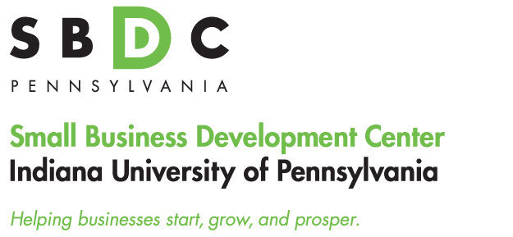
ARCADIA INDUSTRIAL CORPORATION

Indiana University of PA SBDC
Tony Palamone, Director
108 Eberly College of Business
Indiana University of PA
Indiana, PA 15701
(570) 577-1249
tpalamon@iup.edu
www.eberly.iup.edu/sbdc

Success Story

Client Name Tim Shock
Company Name Arcadia Industrial Corporation
Address 2637 Gypsy Road
Glen Campbell, PA 15742
Indiana County

Industry: Machine Shop

Year Founded: 1999

SBDC Assistance: Business Plans & Financial Projections

Additional Partners: Indiana County Office of Planning & Development, State of Pennsylvania – Loan Fund

Background

This company was established in 1999. At that time the IUP SBDC
helped with their original business plan. The company did moderately well in the wake of 9/11, but did not really start to expand until two new owners bought into the company and began a marketing push that resulted in increased sales and additional target market segments. Sales have increased 75% over the last three years.

The company provides machining capabilities to various industries including the steel, powder metals, and carbon industries as well as mining, aggregates and for engineering firms. Additionally, the company produces replacement parts for cranes, draglines, and mining equipment

The company has come back to the SBDC to help with a business plan to expand their original 10,000 square foot of work space by adding a new structure of at least 6,000 square feet. Adding this space will allow for a moderate expansion in the short term and make room for future expansions. At a minimum it will allow for the company to provide for a better work flow and create efficiencies in the production process. At present they production floor is overcrowded as they have added machining capability to the point that they have too many machines in too small a space. A physical space expansion will actually result in increased throughput and the ability to accept more contract work.

Employment has now reached 23 and they envision adding 12 new workers over the next three years.

The IUP SBDC worked with the owners on the original business plan and has been called upon to assist two more times as the company has expanded. In the first expansion plan the company sought and obtained additional machinery. In the second expansion plan they intend to undertake an expansion of the space in which they can do production work. The SBDC is pleased to have been able to assist with this project as it has resulted in good paying jobs in a rural location where there is very little manufacturing

