Success Story
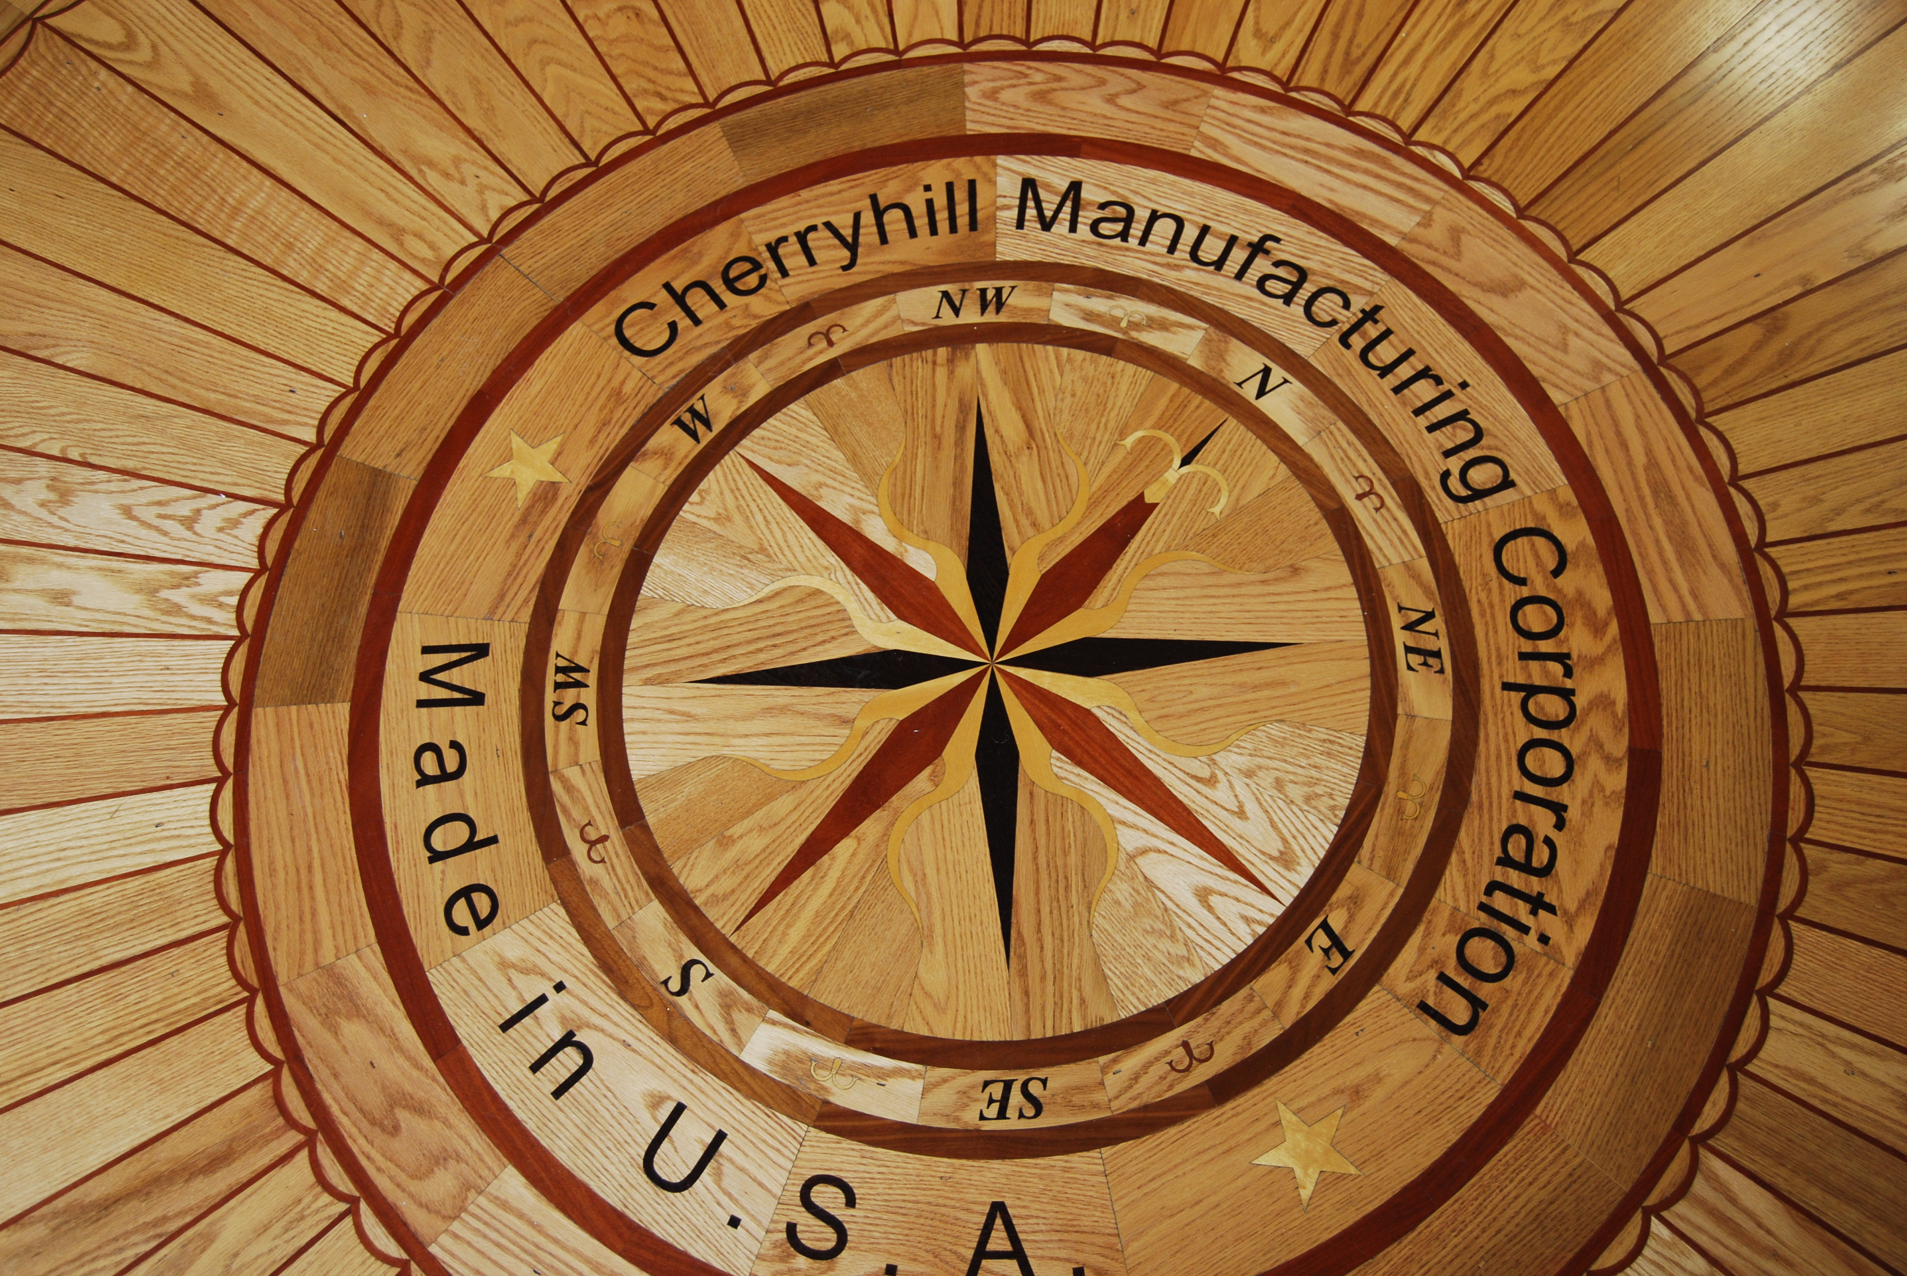

Client Name: Cyrus Kirsch
Company Name: Cherryhill Manufacturing Corporation
Address: 640 Kolter Drive
Indiana, PA
Indiana County
http://www.cherryhillmfg.com/

Industry: Wood floor sanding & finishing equipment manufacture and sales, wood decorative inlays manufacturing and sales and contract manufacturing

Year Founded: 1999

SBDC Assistance: Assistance with market research, initial website design, product logo, software selection for manufacturing process, operations planning, job descriptions.
“The SBDC has a unique networking ability, they connected us with other local companies to fill our needs. And the resources they have for student research projects is very valuable to start-up companies. Good Job! IUP’s SBDC group.
Cyrus Kirsch


Background – The Challenge

The methods and technology to sand floors had not changed much in 50 years. The founders of Cherryhill Manufacturing recognized this fact and decided to improve on the traditional belt sander by applying random orbit technology to floor sanding. They developed a proto-type machine. The proto-type not only was easier to use making floor sanding more accessible for the average do-it-yourselfer, but its use resulted in a better quality finish. Having identified a market opportunity and designed a basic solution, they now needed to: evolve and refine the concept from their rough prototype into a finished market ready product, establish a company and to take that product to market. In short, they were faced with the challenge of moving beyond the concept stage onto and through commercialization. They received the help they needed from the Indiana SBDC. That initial product, the U-sand® floor sander, has found a great deal of market success and become the foundation of a substantial company with a whole product line of synergistic products.

The Problem

Refining a prototype into a finished market ready product
Raising product development funds
Raising operating funds
Field testing
Starting a company
Developing overall market data
Developing a business plan
Setting up a manufacturing assembly operation
Developing promotional literature
Developing technical manuals, instructions and videos and having the manual translated into French and Spanish
Developing a marketing and pricing strategy

SBDC Assistance

The SBDC at Indiana is fully integrated into an array of business assistance services that are designed to maximize the help available from the faculty and students at the Eberly College of Business and Information Technology. As a result the IUP SBDC was able to help with all of the above tasks. The company was launched in 1999 on the basis of the U-Sand®, which has revolutionized and greatly simplified how floors are sanded.

Results

The company continues to achieve a greater and greater market penetration with their initial product, but now has additional products on offer. Their product catalogue, which can be found at http://www.cherryhillmfg.com , offers the U-Sand®, the Super Bee ™(a more powerful contractor version), the U-Sand® Maintainer (a heavy duty buffer), and the U-Sand® Vac Mini. Additionally, they are in the process of introducing two new products. First, a lighter version of the original machine known as the US-Pro Unit and a powerful hand held sander, the US-Mini that can be used on materials other than wood, e.g. granite counter tops. The company also produces beautiful wood inlays and borders and is set up to handle contract manufacturing.


Indiana University SBDC
Tony Palamone, Director
108 Eberly College of Business & Information Technology
Indiana, PA 15705
(724) 357-7915
www.eberly.iup.edu/sbdc

Cherryhill Manufacturing Corporation


