Success Story

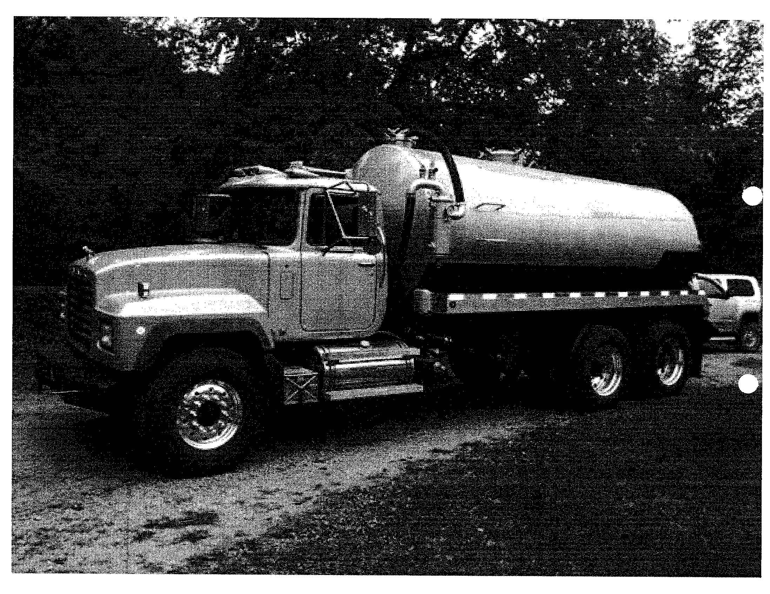

Client Name: Daron Murton
Company Name: Deuce Transport
Address: Mineral Point, PA
Cambria County

Industry: Natural Gas - Water Hauling

Year Founded: 2008

SBDC Assistance: Assistance with financial projections and a business plan
“The SBDC was a great help in getting my business up and running.”

Daron Murton



Background – The Challenge

The development of the gas reserves in the Marcellus Shales holds the promise of significantly assisting in America’s quest for U.S.-based energy sources and of being an economic stimulus for Pennsylvania. The effects of the development of the Marcellus Shales will not only effect gas production companies, but will reverberate throughout the economy. Among the effects are: that this development will draw new companies and residents to the state, jobs will be created for existing residents, the hospitality industry will be effected as area motels fill up, and new companies will be spawned to support the industry.

Indiana County is in the heart of the gas production region and has been heavily engaged in the industry for decades. The development of the Marcellus Shales, however, involves new production techniques and services.

The Problem

Daron Murton has worked as a well tender for 10 years and is intimately familiar with the industry’s needs and with movers and shakers in the industry. He became aware that to produce gas from the Marcellus Shales, the process would require companies to have access to additional water at the well site. Existing production techniques require the use of water to drill and frac the well. Additionally, the brine water extracted as a by product of the process must be disposed of in an environmentally safe manner. Drilling into the Marcellus Shale requires from 20 to 100 times the water as a conventional well drilled into sandstone layers.

Daron envisioned buying the needed equipment to begin a company to haul water as a support service for the industry and building it into a substantial company. He knew the industry, knew key players and knew he could obtain contracts to serve that industry. He needed assistance, however, to package his plan in a way that bankers could assess the deal and make a lending decision.

SBDC Assistance

The SBDC assisted by helping Daron put together a business plan complete with financial projections that clearly documented the nature of the opportunity. Realistic revenue and expense projections were created that documented the ability of the company to repay debt in the short term, but also to layout the potential for growth over a longer term.

Results

Daron Murton was able to acquire the significant amount of capital he needed to purchase the equipment he needed to launch the business. He has begun and obtained a number of contracts to serve the industry. Additionally, he has put in place an organization well positioned to expand with the industry.

The development of the Marcellus Shales is occurring, but much slower than many envisioned. The recent drop in energy prices and the fact that the State of Pennsylvania is wrestling with putting in place regulations to protect the environment has created uncertainty. Uncertainty regarding these issues has slowed development, but massive development will come and when it does Deuce Transport will be well positioned for growth.

Indiana University SBDC
Tony Palamone, Director
108 Eberly College of Business & Information Technology
Indiana, PA 15705
(724) 357-7915
www.eberly.iup.edu/sbdc

Deuce Transport
& the Marcellus Shales


