



Indiana University SBDC
Tony Palamone, Director
108 Eberly College of Business
Indiana, PA 15705
(724) 357-7915
www.eberly.iup.edu/sbdc

Cessna Motorsports Makes a Comeback
Success Story

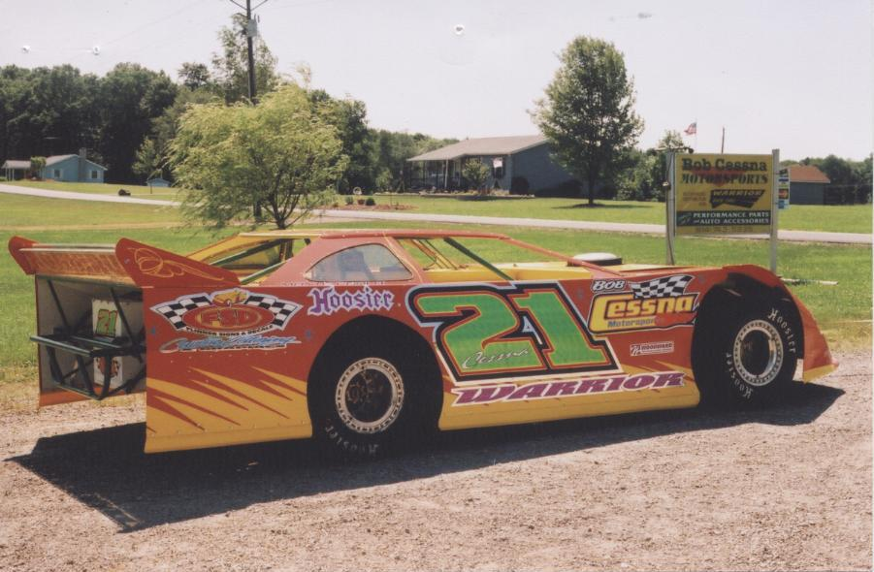

Client Name Bob Cessna
Company Name Cessna Motorsports, Performance Parts and Accessories
Address 3386 Pioneer Lake Road
Cherry Tree, PA 15724-8127
County Indiana

Industry: Motor Sports

Year Founded: 2000

SBDC Assistance: Business plan development, financial packaging and grant writing

Additional Partners: Office of Vocational Rehabilitation, Indiana County Revolving Loan Fund, First Commonwealth Bank.
Bob Cessna is a young man with a passion for motor sports, who started his business as a sideline and hobby in June of 2000. Initially, because of his love for racing he built a race car. He then became a dealer in order to get parts more cheaply and to help others acquire specialty parts. Sales took off more rapidly than he had anticipated as many racers and others were looking to Bob to get them their specialty accessories.

Unfortunately, Bob who worked full time became disabled as a result of a botched medical procedure in November of 2003. Bob was only 28 years of age. Bob’s parents kept the growing business going as he went through recovery. Although officially disabled, Bob wanted to earn his own way and to become reengaged with his passion, motor sports. Bob was ready to resume the leadership role and to grow the business, but he was in need of some help. In August of 2005 he approached the SBDC for some help in putting together a plan.

The SBDC worked with him to put together a plan that included a range of loans and grants that would enable him to manage his disability, work on race cars and grow his business. The funding applications were successful and Bob is now reengaged and is actualizing his dreams.

Cessna Motor Sports will offer a variety of products and services. These will include: Warrior chassis, chassis of Bob’s design, custom built bodies, control arms, spindles, brake components, and shocks and springs for race cars. For the auto and truck lovers Bob will carry everything imaginable to customize the vehicle these items will include: grill guards, tonneau covers, sun visors, vent shades, running boards and wheels.

Bob purchases bare chassis from Warrior Chassis out of Tennessee. The business then engages in the manufacture and fabrication of parts designed to mount to these chassis. The fabricated parts are generally made using chrome moly and DOM tubing. These parts include: control arms, spindles, torque arms, bumpers and rub rails. Using these components as well as others that Cessna has fabricated they install the steering components, suspension components, wiring, gauges and fuel system to the chassis. They also fabricate and install the body to the chassis. The value added by these fabricated parts comprises over 90% of the eventual sale price.

Servicing of race cars is also a large part of Cessna Motorsports business. These services now include race car set-up, tuning, frame repair, spring testing and trouble shooting.

The financing package allowed Bob to purchase a chassis dynamometer which allows Cessna Motorsports to better market their shop and performance accessories. For the uninitiated, a chassis dyno is an excellent diagnostic tool and probably the greatest tuning tool ever invented. The dynamometer would help them separate from the competition in a variety of ways including the ability to promote power packages by offering both before and after fuel mileage and horsepower results. This dynamometer acts as a draw, which is important for this business which is located in a very rural area.

The total expansion package included $152,265 in new investment combined with the $140,900 Bob Had already invested in his business

