**Storeroom – Search for information using a reservation number**

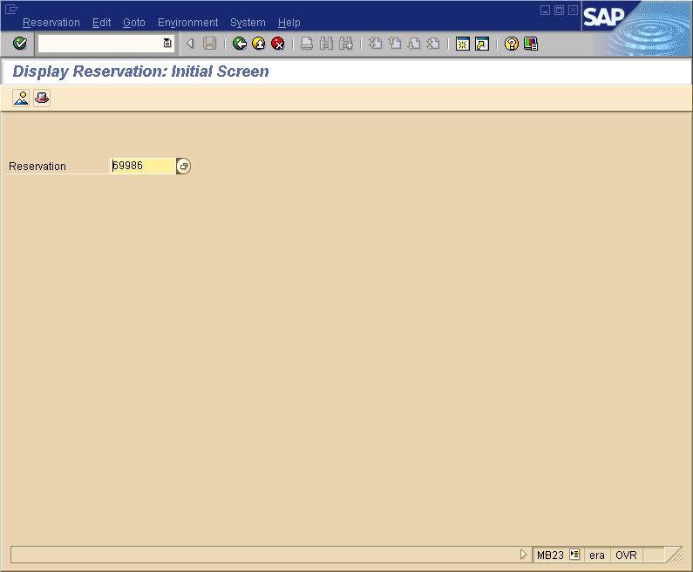

**Display Central Storeroom Reservation**

SAP Transaction **MB23**

**Enter reservation number**

Click **enter** or **click on green check/circle**

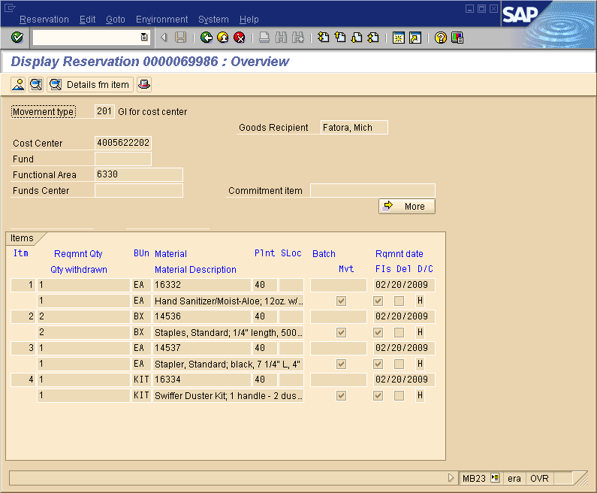

**To drill down for additional information:**

**Place your cursor on a material number**

Choose **Environment** at the top of the screen

Choose **Material Document for Material**

**Display Reservation Overview**

**You will now see your reservation displayed**

**If there is a check in the FIs Column**

The item has been issued to you

**If there is not a check in the FIs Column**

The item has not yet been issued

May be on backorder

You will receive as soon as it arrives

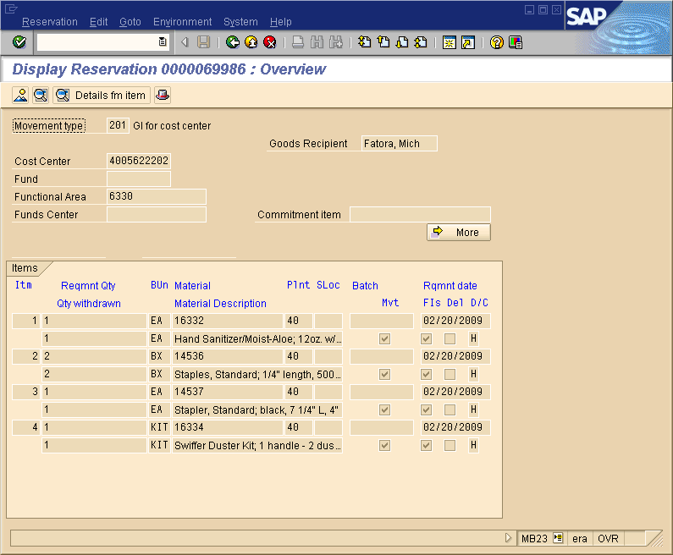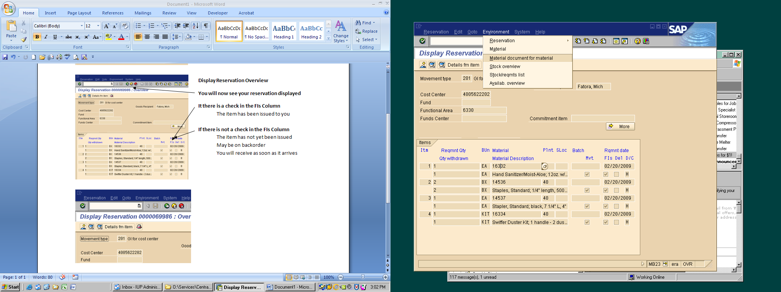

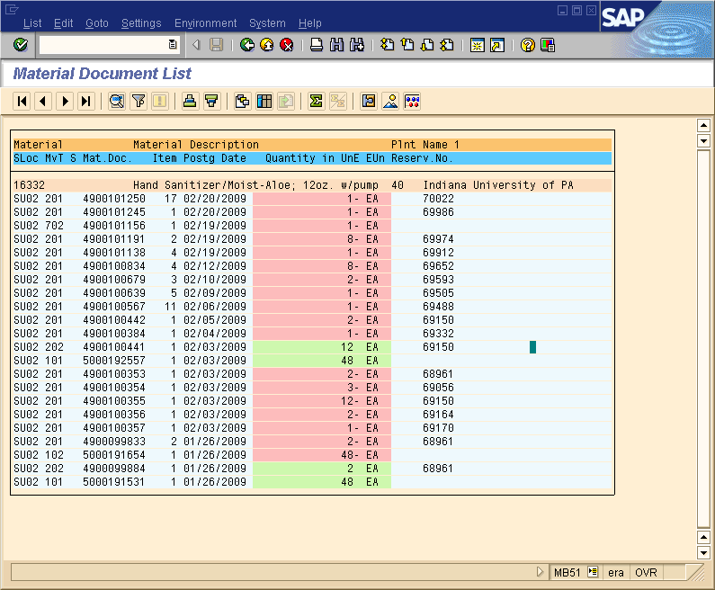

Choose **Settings**

Choose **Layout**

Choose **Choose**

**You will then choose your custom layout**

**The Material Document List will now appear**

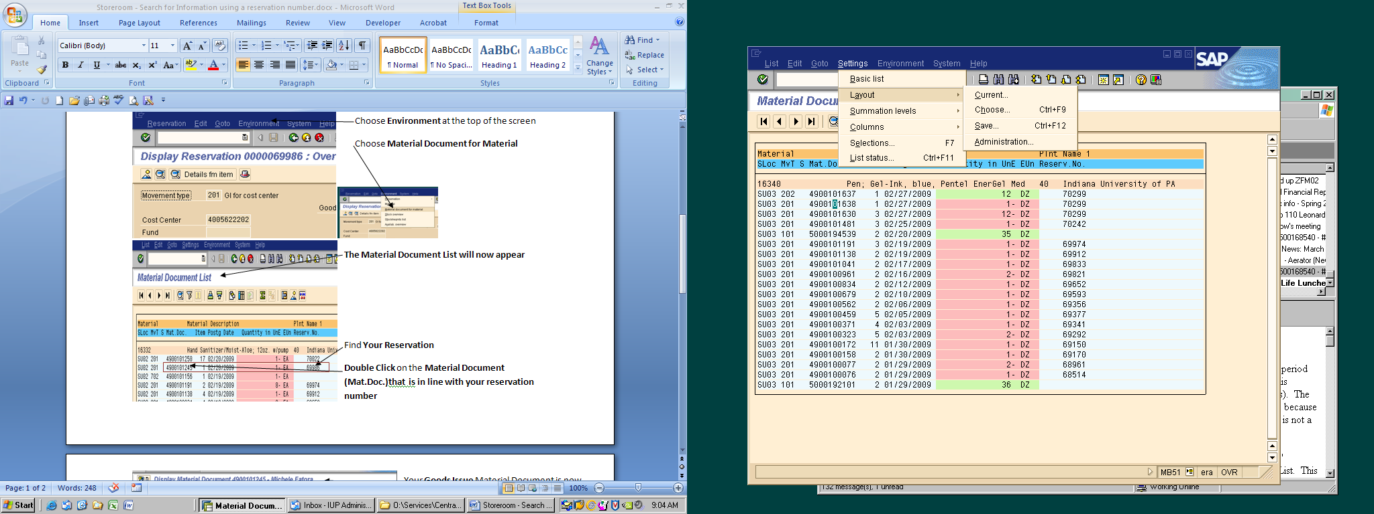

Find **Your Reservation**

**Double Click** on the **Material Document (Mat.Doc.)that is in line with your reservation number**

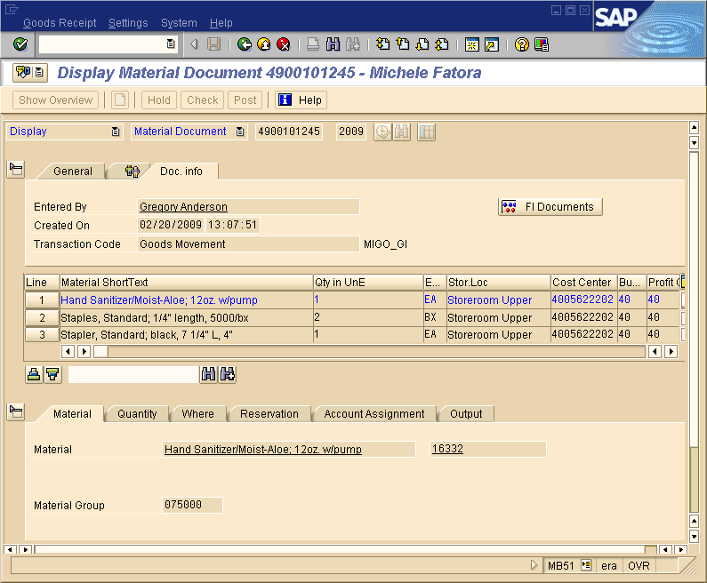

Your **Goods Issue** Material Document is now displayed

Be sure **Doc. Info** tab is on top

Any material on this form has been issued on SAP and you should have received or will be receiving.

**It will show:**

Who in the storeroom issued the reservation

When it was issued

What items are on this material document

You will also be able to drill down the the financial/budget information for this material document

**Click** on the **FI Documents Button**

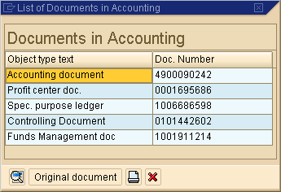

**Documents in Accounting** window will appear

Double Click on **Accounting Document**

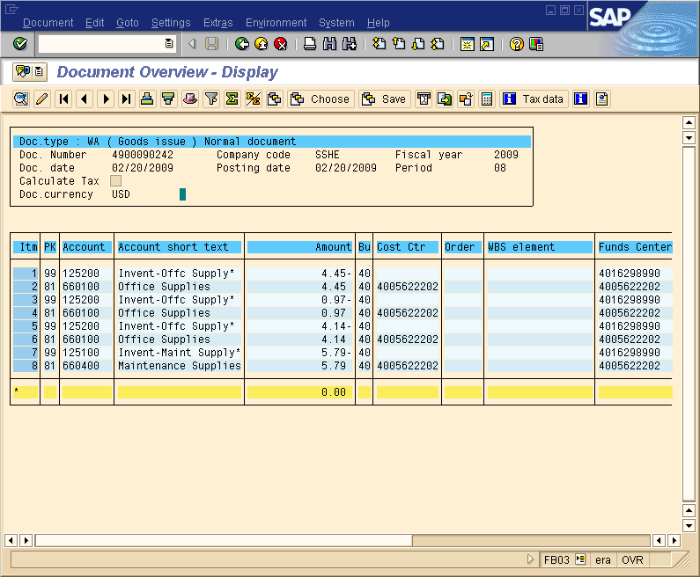

**Document Overview - Display** from the budget will now appear

This is the same form you would see if you were drilling down from within your budget report.

Revised 5/31/11