
¡Oye! Alumni & Student News
Spanish
Department Alumni & Student Newsletter

Department of Spanish, Indiana University of Pennsylvania, PA 15705 ph. (724) 357-2325
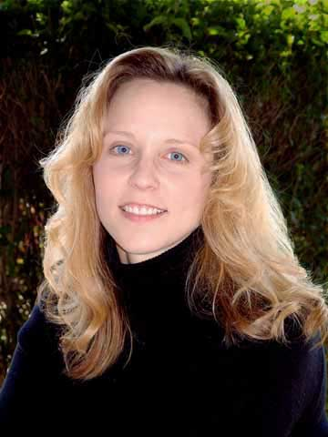
Letter from the Department Chair
Dr. Laura Delbrugge
¡Feliz Año Nuevo! Greetings all and welcome to the first annual IUP Spanish Department Newsletter. The past year has been one of change and transition for the IUP Spanish Department. We unexpectedly lost our dear colleague, Dr. Caroll Mills Young, in September of 2006. Dr. Young was a beloved colleague, professor, mentor, and friend to all of us, and she is deeply missed in the department. An on-campus memorial service was held in her honor on November 3, 2006 in Gorell Auditorium. All present will never forget the touching tributes given to Dr. Young by her students, colleagues, and friends. The most recent issue of the Hispanic Journal was dedicated to Dr. Young.

In 2006 we also lost Jessica L. Aaron, a Spanish minor, who died suddenly in February. For more information, including how to contribute to the Jessica L. Aaron Memorial Study Abroad Scholarship, see the feature in this letter.

Another transition for the department was the January 5, 2007 retirement of Dr. Victor Drescher after thirty-five years of teaching. In addition to teaching, Dr. Drescher established the Met Life Translation Center and was its director. Dr. Drescher also was responsible for the highly successful Critical Languages Program at IUP. He was very active in the Costa Rica Study Abroad Program and served as its on-site director many times. In fact, Dr. Drescher has established an endowed scholarship fund for study abroad scholarships, testimony not only to his love and devotion to the study abroad experience, but also to his exceptional generosity. It is no exaggeration to say the Dr. Drescher will be truly missed on campus, but as he intends to spend much of his retirement in Costa Rica, we are certain he will enjoy his new-found freedom. Dr. Drescher’s Met Life and Critical Languages duties will be assumed by Dr. Sally Thornton, and Dr. Sean McDaniel serves as the 2007 Costa Rica Study Abroad Program Director.

This year the Spanish Department was pleased to welcome back Professor Begoña Llamas-Giner to teach for the department, as well as Professors Dan Murphy and Marcia Behr. In addition, Professor Mark Rice will be joining the staff as a full-time temporary professor beginning in the Spring Semester 2007.

The Department was part of the university-wide successful NCATE re-accreditation process that took place in 2005-06. The Spanish Education Program was honored in August of 2006 with a National Recognition for excellence, at the time being only one of twelve Spanish Education programs nationwide to receive such a designation. All of you who participated, or who are participating, in the Spanish Education Program know how fantastic it is, and it is wonderful to see it recognized at a national level. Congratulations to Dr. Eileen Glisan and the entire department faculty for achieving this distinction.

For those of you who don’t already know, the Spanish Department has been given the green light by the PASSHE system to develop a Master’s Degree! Work has already begun on the degree, which will have two tracks, one in literature and one in education. The department hopes to accept its first master’s students in either fall 2008 or fall 2009. For more details and information about the progress of the program, please contact Dr. Sean McDaniel (mcdaniel@iup.edu) or Dr. Dawn Smith-Sherwood (smithshe@iup.edu). We hope to see many of you continuing your studies in Spanish with us at the graduate level.

In addition to the development of a masters program, the department will offer a new minor beginning fall 2007. The Minor in Spanish for Elementary Education will replace the previous concentration known as FLISET. The new minor will be unique in that it requires participation in the Mexico Summer Study Abroad Program.

Departmental study abroad programs continue to attract record numbers of participants. The 2006 Cuernavaca program took 24 students, and there are 18 participating in the spring 2007 Valladolid experience. In addition, there are two students participating in the semester-long Universidad de las Américas program this spring in Puebla, Mexico. Another full contingent is expected for the summer 2007 Costa Rica Program as well. We’re on a roll!

The departmental publication, the Hispanic Journal, continues to produce top-quality volumes, attracting scholars from literally all over the world. Dr. Liliana Jurewiez is the General Editor of the Journal, and is doing a wonderful job, completely redesigning the layout of the publication. Dr. José Carranza continues to serve as the financial editor of the Journal, a task he has done for many years.

The 32nd Annual Hispanic Literatures Conference was held at IUP on October 6-7, 2006. The topic for the year was film and literature, and dozens of participants from all over the world contributed to make the event as memorable as always. Many of our current students as well as some alumni participated in the Congress. The 2007 Congress will be held in October. Watch the website for updates as to how to submit papers for consideration.

The IUP Spring Methodology Conference on Foreign Language Teaching will be held Friday, April 27, 2007 at the Indiana Holiday Inn here in Indiana. After a two-year hiatus, this year’s conference is a much-anticipated event. A full slate of presenters and participants, over two hundred, are expected to attend. For information about the conference, including contact persons, please see the department website, www.iup.edu/spanish. We would love to see many of our alumni there!

We are also pleased to announce that Dr. Marveta Ryan-Sams is expecting a baby, which is due in April. Dr. Ryan-Sams is on leave this spring semester, but will be back in the fall. We all wish her the best, and if you would like to send her your good wishes, you can email her at mmryan@iup.edu.

So, we all hope this newsletter finds you well. Please read the features and updates, and be sure to send us your contact information as well as any tidbits you’d like to share so that we can all reconnect. We would love to include your updates in our future issues.

Sinceramente,
Laura Delbrugge

IN MEMORY

DR. CAROLL MILLS YOUNG
We have the sad task of informing you of the death of Dr. Caroll Mills Young. Dr. Young had been a Professor in the IUP Department of Spanish since 1988. She was an internationally-renowned scholar in Afro-Hispanic Literature, publishing numerous journal articles and book chapters, as well as presenting her findings at many international and national venues. Dr. Young served her discipline in many ways, including holding leadership positions in the College Language Association.

Her willingness to serve her department, her college, and her university was well-known to all. Dr. Young served on dozens of committees, including Liberal Studies, Faculty Professional Development, Pan African Studies, Middle States Steering, and the CHSS Research Committees, as well as many others. Dr. Young was deeply committed to serving students, and as such served as chapter President of IUP’s Phi Kappa Phi, as well as graduate advisor to the Alpha Kappa Alpha Sorority. Dr. Young was director of the IUP Spanish Department’s study abroad program at the Universidad de las Américas in Puebla, Mexico. Dr. Caroll Mills Young was an admired researcher, respected colleague, and beloved friend. She will be deeply missed.

Those who wish to remember Dr. Young may do so in the following ways: (1) Dr. Caroll Mills Young Scholarship Fund, in care of Michelle Twiggs, 2711 Elizabeth Ave., Shelby, NC 28150; (2) College Language Association Study Abroad Scholarship, College Language Association, 12138 Central Ave., Suite 576, Mitchellville, MD 20721; and (3) Christian Education Department, Mid-Atlantic I, Episcopal District, Allegheny Conference, A.M.E. Zion Church, in care of Ms. Loretta Sutton, 5009 Rosecrest Drive, Pittsburgh, PA 15201.

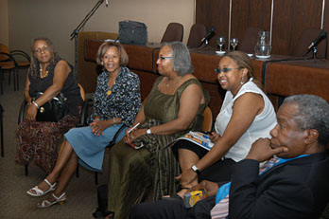
Here we see Dr. Caroll Mills Young (center of photograph) in attendance at a conference held in February, 2006 in Montevideo, Uruguay. Click here for an article about the conference.

FACULTY NOTES


DR. PETER BROAD
Dr. Broad has now completed 20 years at IUP. Once upon a time he received his B.A. from Dartmouth College and his M.A. and Ph.D. from the Johns Hopkins University. Last summer, having forgotten why he gave up the chairmanship many years ago, he filled in as chair for Dr. Delbrugge during her sabbatical. This past year he presented a paper on the effects of being an expatriate in the novels of three Colombian writers at a conference at the University of New Mexico and another on Rosario Castellanos’ Oficio de tinieblas in Monterrey, Mexico. His study of José Emilio Pacheco’s Morirás lejos came out in a volume of studies on Pacheco published by Siglo XXI in Mexico. In August, Dr. Broad and his wife attended the international ProZ conference (translators and interpreters) in Buenos Aires. They took advantage of the three-day conference to spend two and a half weeks touring in Argentina (with a day trip to Uruguay). This fall he learned more than he had planned to about Afro-Caribbean writers when he was called on to complete Dr. Ryan-Sams’ SPAN 481 course after she went on medical leave. Dr. Broad continues to be heavily involved with the Hispanic Literatures Conference and with APPLES, the college-high school collaborative started many years ago by Dr. Glisan. He is also an active member of the University Senate.

DR. FRANK B. “Pete” BROOKS
Dr. Brooks, Associate Professor of Spanish, is in his second year of teaching in the Department after 15 years in second languages education at The Florida State University. He specializes in applied linguistics and foreign languages education and teaches beginning Spanish, Spanish composition and conversation, as well as coordinates the Pre-Student Teaching 1 experiences, and advises students in Spanish Education. His research interest is in the area of applied classroom discourse analysis and has published his research in various national and international journals, such as Modern Language Journal, Hispania, Language Learning, and Foreign Language Annals. He is also the recipient of the 2006 ACTFL-MLJ Paul Pimsleur Award for Research in Foreign Language Education. Dr. Brooks also coordinates the Mexico Summer Study Abroad Program.

DR. JOSÉ CARRANZA
Dr. Carranza was in charge of the spring and summer 2006 study abroad programs in Valladolid. He also advises all Spanish minors and collaborates with the production of the Hispanic Journal as the person in charge of subscriptions and exchanges with other publications.

Dr. Laura Delbrugge
Dr. Delbrugge, Associate Professor and Chair of the Department of Spanish since 2004, received her Ph.D. in Spanish from Penn State University in 1996, with specializations in Spanish medieval literature and historical linguistics. Her past projects include the publication of an edition of Andrés de Li's 1495 almanac, the Reportorio de los tiempos, with Tamesis Press in 1999, as well as numerous presentations at the International Congress of Medieval Studies in Kalamazoo, Michigan. She completed a second book, A Critical Edition of Andrés de Li's Summa de paciencia (1505) in 2003. Dr. Delbrugge is currently working on a third edition, the Tesoro de la Pasión, and will be traveling to Spain in May 2007 to conduct primary research. Dr. Delbrugge is also a member of the University-Wide Promotions Committee.

DR. VIC DRESCHER
Dr. Drescher, Professor of Spanish, recently announced that he was offered an opportunity to teach in the Master's Program in Translation at the National University of Costa Rica starting in January and retired from IUP this December 2006 after 35 years of teaching.

DR. EILEEN W. GLISAN

Dr. Glisan, University Professor and Professor of Spanish, teaches Spanish language, linguistics, and teaching methodology and coordinates the Secondary Education/Spanish Program at IUP. During Academic Year 2004-2005, she was the Distinguished Visiting Professor in the Department of Foreign Languages at the U.S. Air Force Academy in Colorado Springs. She is co-author of Teacher's Handbook: Contextualized Language Instruction, now in its third edition, and she was recently re-certified by the American Council on the Teaching of Foreign Languages as an oral proficiency tester of Spanish. Dr. Glisan co-directed the project that created the ACTFL/NCATE Program Standards for the Preparation of Foreign Language Teachers, approved by NCATE in 2002. She has been involved in designing the ACTFL Integrated Performance Assessment (IPA), which appeared in an article in the fall, 2006 issue of Foreign Language Annals. Dr. Glisan was named Distinguished University Professor by IUP for 2000-2001. Additionally, Dr. Glisan was the 2006 recipient of the Kappa Delta Pi Excellence in Education Award at IUP. This award is given to a faculty member who consistently goes above and beyond what is required of them and has a significant impact on the education majors in their area of expertise.

DR. LYDIA H. RODRIGUEZ
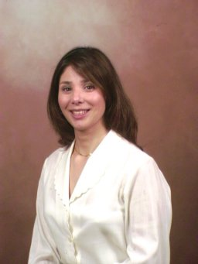
Dr. Rodríguez, Associate Professor, is now in her seventh year at IUP. Over these past seven years, she has devoted herself to furthering the understanding of Latin American women writers and US Latinas in general. She has taught and teaches the Spanish language, Spanish American and US Latina literature and culture classes. Aside from her national and international article publications and presentations, in 2005 she published her first book El mestizaje del canon: Helena María Viramontes (Spain: Pliegos) and in 2006 completed and published her second book Helena María Viramontes en sus propias palabras (New York: ENE). Dr. Rodríguez was awarded a Proclamation of Recognition by Mayor Adrián Rivera Pérez of Cuernavaca, Mexico for promoting the Spanish language and culture abroad (2005). In 2006 Dr. Rodríguez was invited to La Universidad Tecnológica of Cartagena, Colombia as a guest speaker for the second time. She was also invited as a guest speaker to La Universidad de Simon Bolivar in Caracas, Venezuela. During this last year she created and developed a senior synthesis course entitled The Maya: Culture, Literature and Numbers and she co-created and co-developed an abroad segment of the same course to be offered for credit and non credit (http://nsm1.nsm.iup.edu/falarcon/lbst499 ).

DR. MARVETA RYAN-SAMS
Dr. Ryan-Sams, Associate Professor, is now in her eighth year at IUP. This fall semester she taught a Special Topics course titled "Cultural Roots of the Hispanic Caribbean." This course focuses on representations of Indians and of Blacks in the literature and culture of Cuba, Puerto Rico, and the Dominican Republic. The course grew out of research that Dr. Ryan-Sams has conducted over the past few years. She plans to continue this research as a book project, but at the moment Dr. Ryan-Sams is on leave and is expecting a baby in April, 2007! Stay tuned for further information.

Dr. Sally W. Thornton
Dr. Thornton, Professor of Spanish, has just assumed the responsibilities as Director of Critical Languages and of the Met Life Translation Center. Through its Critical Language Program, IUP this year has offered courses in Arabic, Chinese, Japanese, Korean and Russian. This semester Dr. Thornton is also teaching a Liberal Studies course on gender roles in the Americas and her favorite course, SPAN 412, “The Spanish Novel of the 19th and 20th Centuries.” She continues to do research in Spanish peninsular literature, having presented a paper last year on Pío Baroja’s novel La nave de los locos and published an article on the same author’s novel, El Hotel del Cisne. In keeping with an interest in female writers from Spain and Spanish America, she translated short stories by fifteen contemporary Argentine women writers that were published in book form in December 2003.

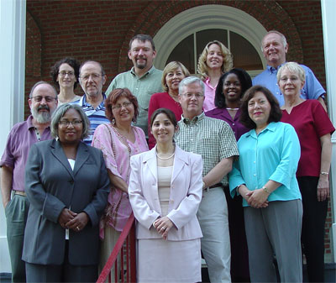
Spanish
Department
Faculty 2005

DEPARTMENTAL RETREAT

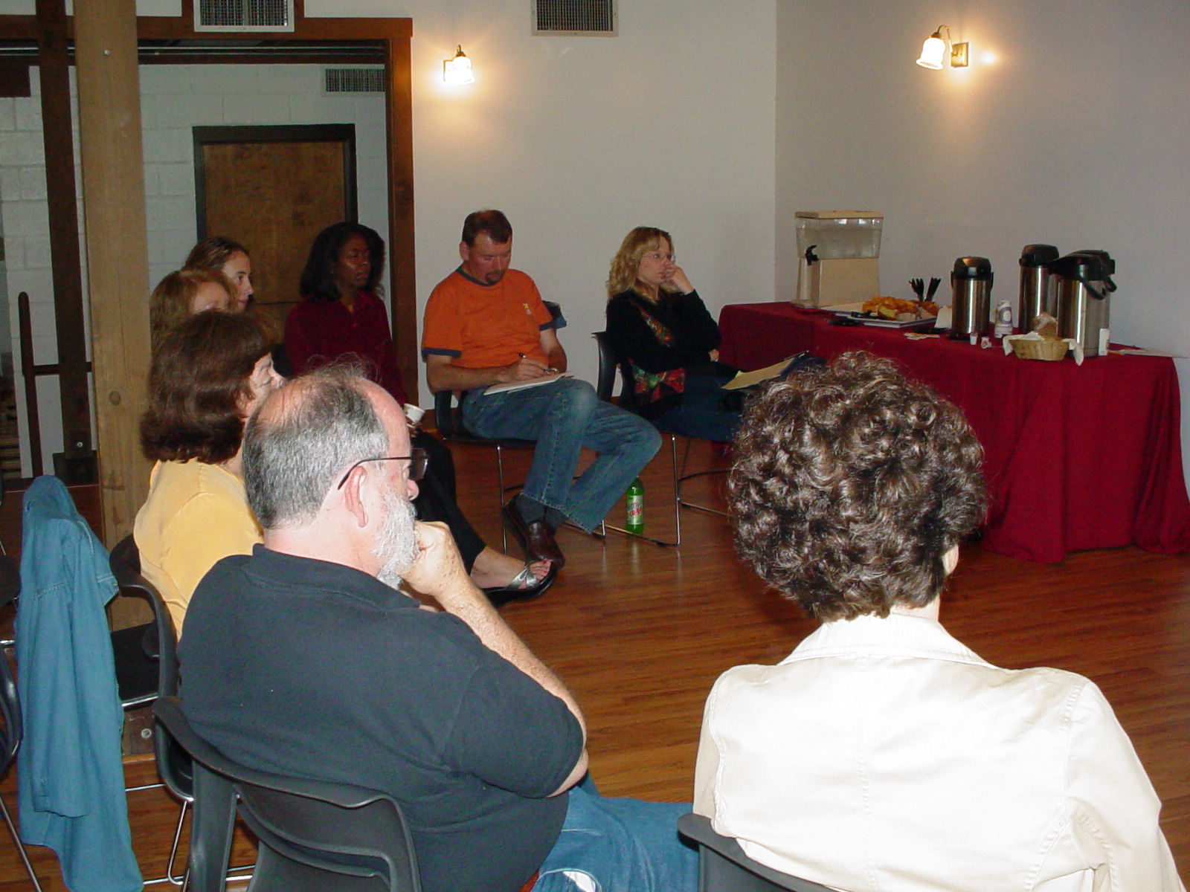
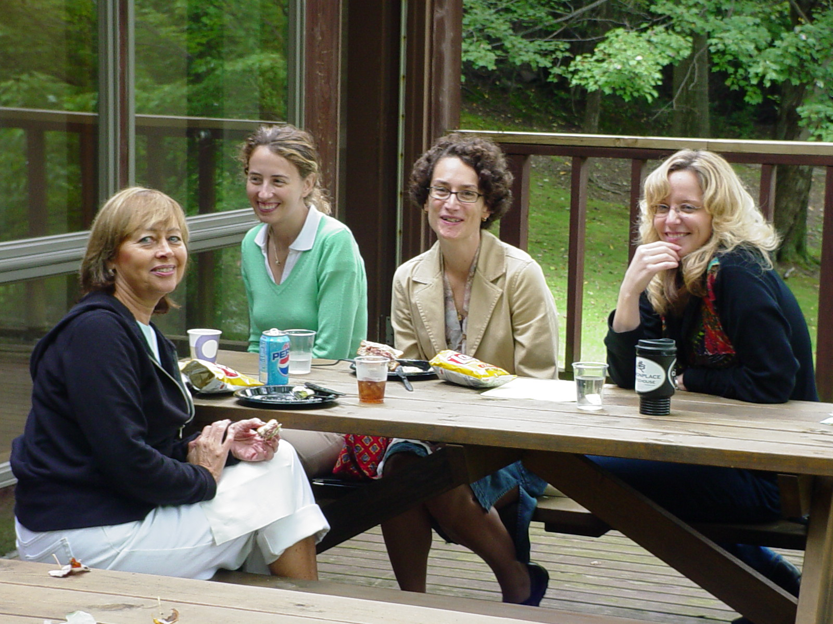
On September 16, 2006 the Department of Spanish held its first faculty retreat in a long time. It was at the suggestion of our dear colleague, Dr. Caroll Mills Young, that we came together at a location away from campus to discuss important issues and concerns for the Department. The day began (picture left) with all of us partaking in a brainstorming session to map out how we were going to proceed that day. As you can see, we had lots of coffee and other delights to get us going, and we also had lunch brought in so we would not lose any momentum. By all accounts, the day was very productive! Do you recognize at least some of the Spanish faculty?

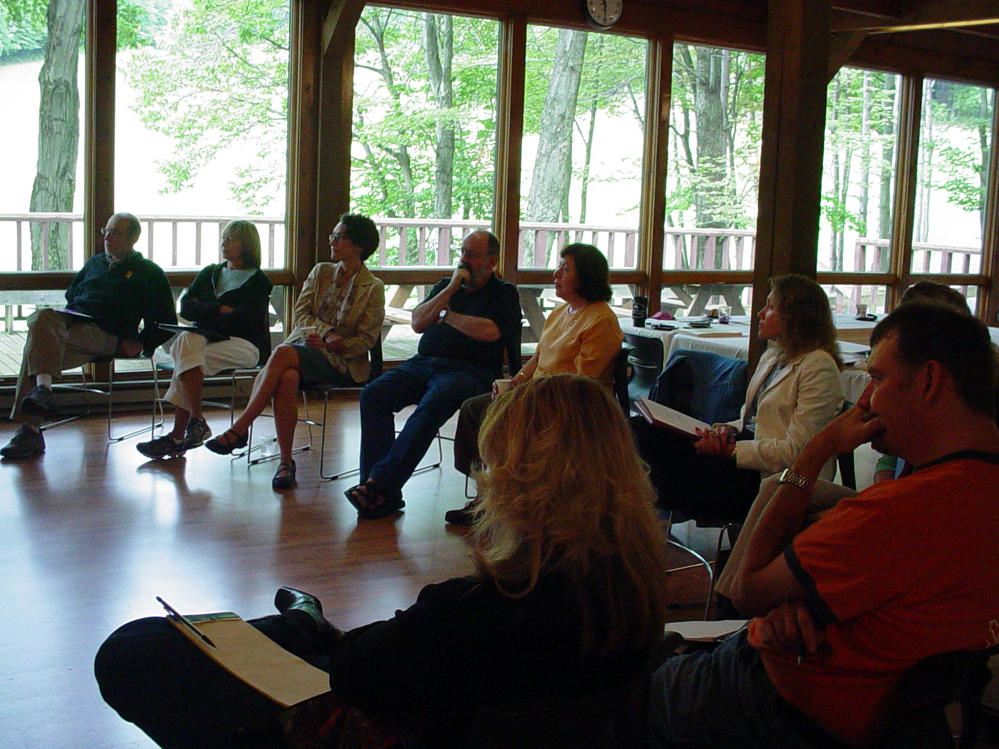
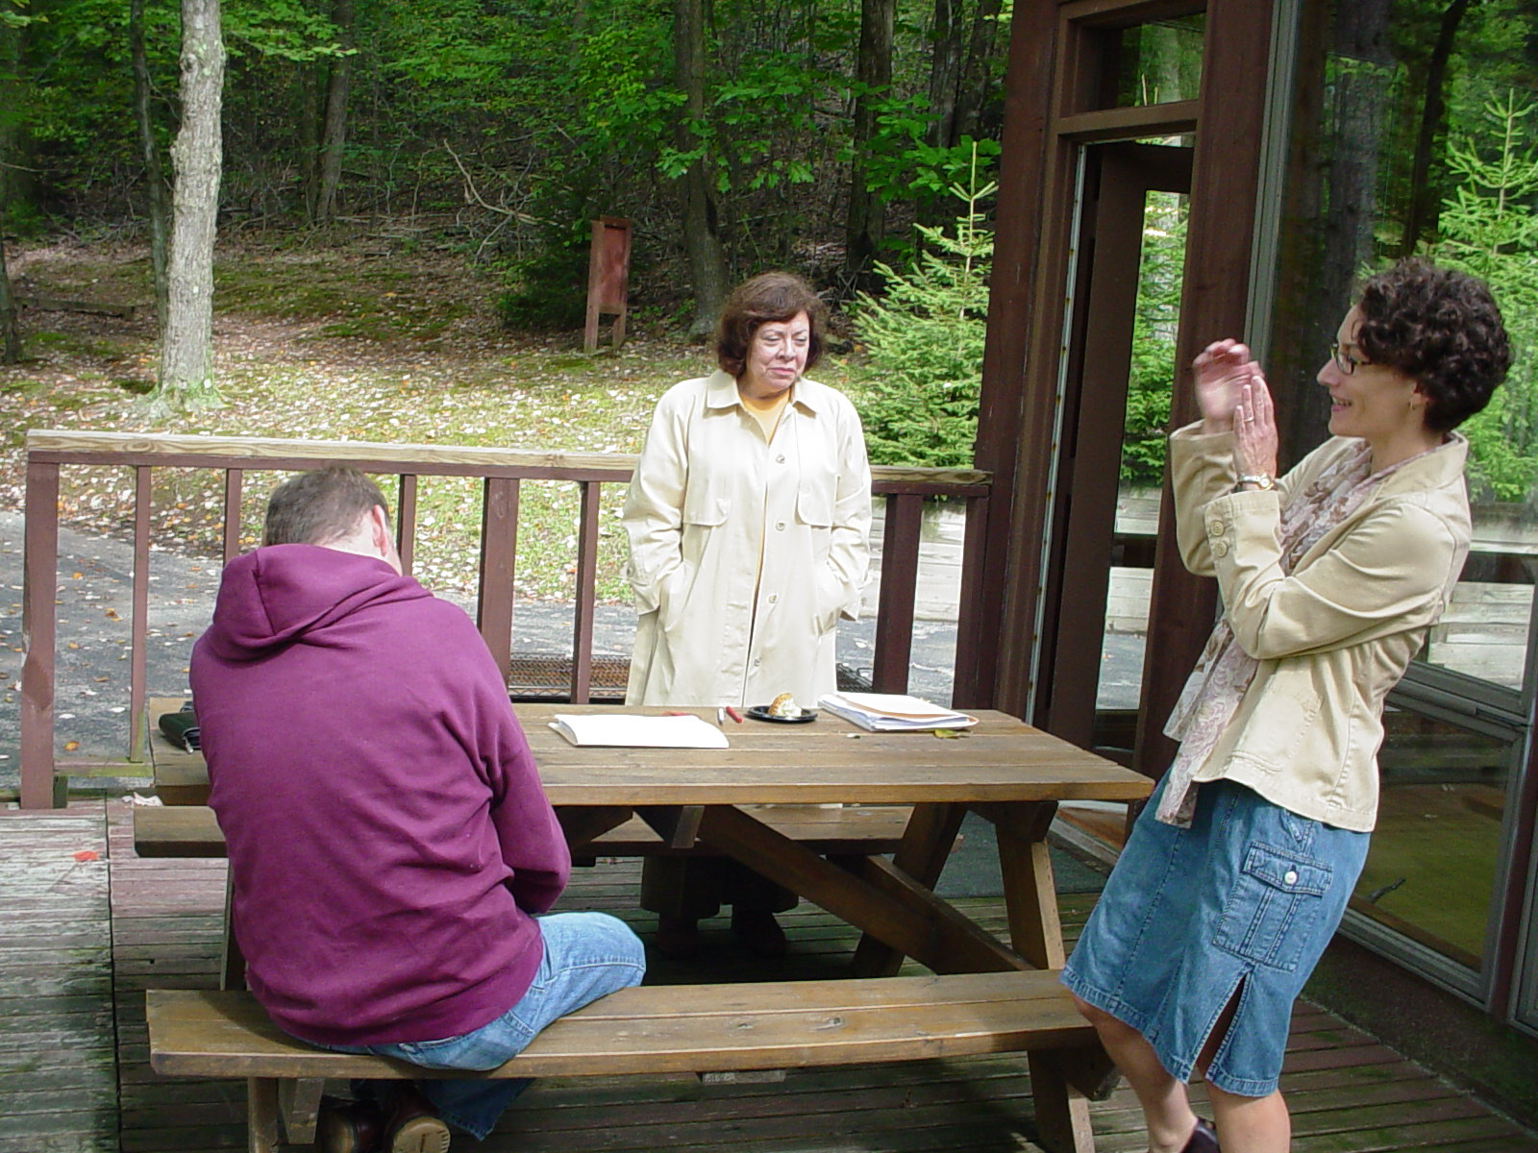
IUP’s SPANISH EDUCATION PROGRAM
AWARDED “NATIONAL RECOGNITION” BY NCATE

IUP’s Spanish Education Program has reason to celebrate! It has been granted “National Recognition” by the National Council for Accreditation of Teacher Education (NCATE) and the American Council on the Teaching of Foreign Languages (ACTFL) for its exemplary teacher preparation program. ACTFL, a specialized professional association of NCATE, collaborates with NCATE to review foreign language teacher preparation programs in NCATE institutions to determine if programs meet rigorous standards developed by the foreign language profession. To merit national recognition status, programs must prepare a Program Report that provides evidence of having met all requirements of the ACTFL/NCATE Program Standards for the Preparation of Foreign Language Teachers, released in 2002 by ACTFL. Dr. Eileen W. Glisan, Coordinator of the Spanish Education Program, prepared the department’s Program Report.

According to the ACTFL program review report, IUP’s Spanish Education Program “epitomizes the new face of language teacher education” and it “demonstrates clearly the connectedness between the acquisition of knowledge, skills, and dispositions in language and pedagogy.” The report further indicates that “this program provides a model for other foreign language education programs that strive to have their programs nationally recognized.” The program was also commended for its exemplary partnership with the College of Education and Educational Technology.

IUP’s Spanish Education Program is one of only twelve foreign language teacher preparation programs in the country to be nationally recognized by ACTFL/NCATE since 2002.

DEPARTMENTAL ACTIVITIES

The Department of Spanish is a busy place! We offer four different opportunities for our students to participate in meaningful study abroad experiences that include the very powerful home-stay experience. The Valladolid Program at La Universidad de Valladolid, a full semester study program in Spain coordinated by Dr. Carranza, continues to be extremely popular, especially among the Spanish and Spanish Education majors. During the spring semester, 2006, for example, some 14 students participated, and during spring 2007 there are 18 students enrolled. At the end of the semester experience Dr. Carranza usually returns to Valladolid and coordinates the six-week program for students who are able to complete the Spanish 102 and 201 course sequence.
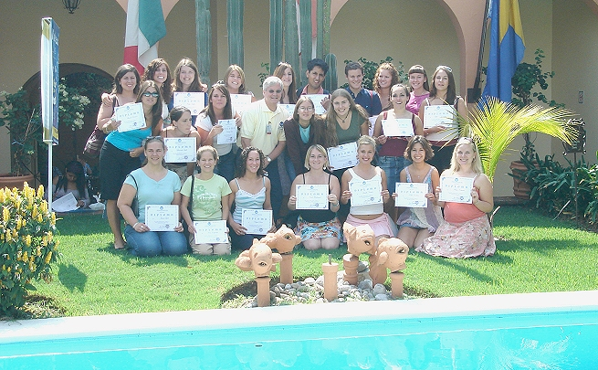
The six-week summer study abroad program in conjunction with the Universidad Internacional in Cuernavaca, Morelos, Mexico also continues also to be popular among students. The minimum requirement is that students have completed at least Spanish 102 before participating. During the summer of 2006 Dr. Brooks took 23 students, all of whom lived with Mexican families. Also popular among students is the four-week summer study abroad program in conjunction with the Universidad Nacional Autónoma, located in Heredia, Costa Rica. Dr. Drescher took 6 students during the summer of 2006 and during summer 2007, Dr. McDaniel will lead another group to that Central American country. There, students can complete Spanish 220, Intermediate Conversation and Grammar.

IUP also works closely with the Universidad de las Américas in Puebla, México where students can arrange to study for an entire semester, taking regular classes (all taught in Spanish, of course!) in many different content areas, such as biology, mathematics, history, and literature with Mexican university students. Arrangements for this program usually take some time to complete so we encourage interested students to begin talking early with Dr. Herlinda Hernández so the necessary paperwork, contacts and arrangements can be completed in time.

In the Department we also offer various cultural and professional opportunities, both for students and for other professionals in the field. Dimensiones Españolas, the student-directed Spanish club as well as Piso Cervantes, a Spanish-oriented on-campus dormitory location allow students to enjoy many different cultural and linguistic opportunities. We also publish annually a journal of student work called Adelante. The Department also offers annually the Hispanic Literatures Conference in October, and on April 27 of this year the IUP Spring Methodology Conference on Foreign Language Teaching will start up again as an annual event after a three-year hiatus. The Department also publishes the Hispanic Journal four times per year.

ALUMNI NOTES

Timothy Crowley (IUP ’83), who was a student at the Armstrong Campus of IUP many years ago wrote and fondly remembered Dr. Vic Drescher’s Spanish classes as well as those of Dr. Hayward. While at IUP he participated in the Valladolid Study program, and says he has “never forgotten a minute of my time there.” He further wrote to Dr. Drescher, “You were wonderful to me as a freshmen student who thoroughly enjoyed speaking Spanish. I'll never forget the test you returned to me via U.S. Mail over a Christmas vacation where you wrote on the top, ‘99%, Best in Class’." Tim now serves as an elementary and middle school principal (20 years), is married with three children, and lives in Rochester, VT, 12 minutes from the Middlebury Snow Bowl and 25 minutes from Middlebury College.
Amy Huggins, Secondary Spanish Ed. (‘05), accepted a position at a new charter school in Tidiute, PA (north of Rte 80). She will be teaching Spanish K-12 in addition to four other languages via the internet. We’re sure many of you remember Amy - she's very excited about teaching.

Sarah L. Conroy, BA in Spanish for International Trade and Valladolid Study Abroad participant, informs us that she has taken a position with Del Monte Foods as a financial auditor. She says that the main reason they gave her a chance is because of her skills in Spanish. For her, it has turned out to be a “dream job.” She has done work in Mexico, American Samoa and Ecuador as well as around the U.S. Her biggest Spanish-intensive task so far has been translating legal documents from Venezuela for their CEO. She writes that she never could have done that with out having taken the Advanced Grammar course here at IUP. Sarah is planning to return to school part-time in January, 2007 to pursue the MBA degree, and she has another trip planned for Ecuador in the spring. “So everything in my life is going really well at this point.”

Kate Kimble, Spanish BA (’06). Kate is currently working on a Master’s Degree in the History Department at IUP. She plans to work with the politics of Carlos V. Kate is also busy as an RA on campus.

IN MEMORY
JESSICA LYNN AARON
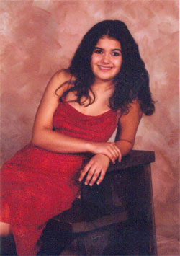
We were deeply saddened to learn that one of our dedicated students in the Spanish Department, Jessica Lynn Aaron, died suddenly on Tuesday, February 28, 2006. She was a sophomore at Indiana University of Pennsylvania, studying toward an academic minor in Spanish. It was at Greensburg-Salem High School where she developed her passion for the Spanish language and its many cultures. In fact, Jessica had visited Costa Rica during high school and continued studying Spanish at IUP. She was also eagerly planning to study in Valladolid, Spain through IUP’s study abroad program during the spring semester, 2007.
Jessica demonstrated to all an intense desire to study abroad where she felt she could really perfect her Spanish, which she had already learned to speak and understand quite well. More importantly, Jessica felt that living in a Spanish speaking country for an extended period of time would provide her the perfect opportunity to immerse herself in the culture.
The Department wishes to perpetuate Jessica’s name in the University and the Department through the creation of the JESSICA L. AARON MEMORIAL SCHOLARSHIP FOR STUDY ABROAD. Through this fund we will extend Jessica’s passion for the language and its cultures by providing financial support to other equally interested students to be able to study abroad and thus live the experience that Jessica so longed for.
You may help us honor Jessica's memory by making a donation to the Jessica L. Aaron Memorial Study Abroad Scholarship. You may make a donation online but please be sure to note Fund #5292 in the comments area. Or, pledge your support using our printable pledge form.
Follow this link to read the Foundation for IUP's statement regarding its registration with the Pennsylvania Department of State and its status as a charitable organization.
Questions may be directed to the Office of Annual Giving at 724-357-5555.


Stay in Touch! Alumni Information Update, Please!

The Department of Spanish is trying to complete and maintain a current contact list of all of our alumni. Please let us know of your current whereabouts and accomplishments!

Name: _____________________________________________________________________
Address: _____________________________________________________________________
_____________________________________________________________________
Phone: ____________________ E-mail: __________________________________________
Year Graduated and degree earned: _____________________________________________________
Current Employer: ___________________________________________________________________
Position & Duties: ___________________________________________________________________
Study Abroad with IUP: _______________________________________________________________
Interesting tidbits about yourself since IUP:

Please send your updates to: ¡Oye! Alumni and Student News, Department of Spanish, Sutton Hall 455, 1011 South Drive, Indiana University of Pennsylvania, Indiana, PA 15705-1046 or e-mail your update to span-alum-news@iup.edu.

 This is an updated address
 This is an updated employment situation
 Please add me to your mailing list / e-mail list
 Please remove me from your mailing list / e-mail list

Please visit the Department website: http://www.iup.edu/spanish

