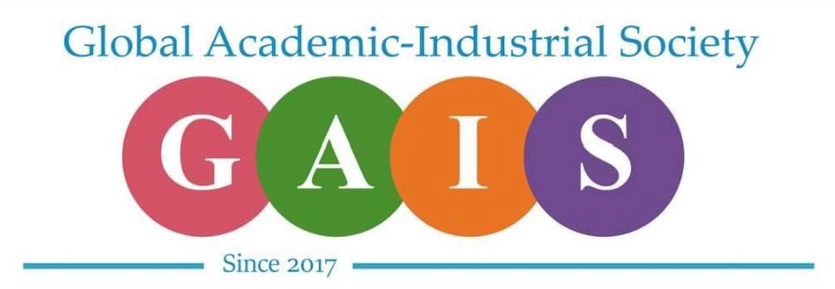

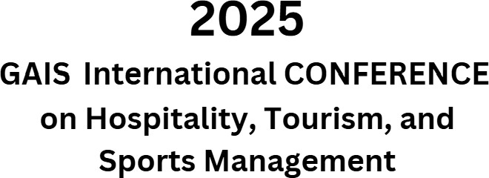

# April 10, 2025

3:00-6:00 p.m. Case Study Competition

Happy Hour (C.H. Fields)

6:30-8:30 p.m. Dinner

# April 11, 2025

Location Hadley Union Building

8:00-9:15 a.m. Case Study Final

(Knowlton)

8:00-9:10 a.m. Registration

(Lobby of the HUB)

9:15-9:30 a.m. Opening Remarks

(Ohio Room)

9:30-10:30 a.m. Main Speaker:

10:40-11:10 a.m. Mini Sessions 1

Susquehanna Room:

Allegheny Room:

Monongahela Room:

Knowlton Room:

Conemaugh Room

11:20 a.m.-11:50 a.m. Mini Sessions 2

Susquehanna Room:

Allegheny Room:

Monongahela Room:

Knowlton Room:

Conemaugh Room:

12:00-1:00 p.m. Poster Presentation

12:05-1:05 p.m. Lunch

(Ohio Room)

1:15-1:45 p.m. Academic Mission Sessions/Call for Papers

(To Be Announced)

1:55-2:25 p.m. Mini Sessions 3

Susquehanna Room:

Allegheny Room:

Monongahela Room:

Knowlton Room:

Conemaugh Room:

2:35-3:05 p.m. Mini Sessions 4

Susquehanna Room:

Allegheny Room:

Monongahela Room:

Knowlton Room:

3:10 p.m. Closing Remarks

(Ohio Room)