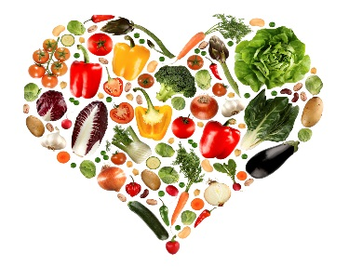

**Sponsored by Dr. Swauger's Sociology of Family class, the Dept. of Food and Nutrition, Dept. of Anthropology, Indiana Community Garden, Zion Lutheran Church, Chevy Chase Community Center, ICCAP, and the Greater Pittsburgh Community Food Bank. Email** [**mswauger@iup.edu**](mailto:mswauger@iup.edu) **for more information.**

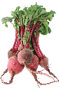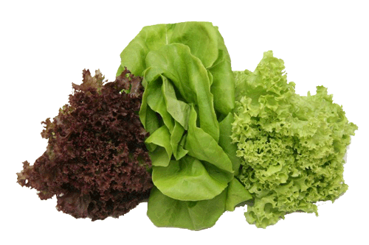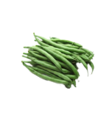

Check out our events!

**Food Drive:** Tuesday- Thursday🡪 April 25th-April 27th,

HUB Cul-de-Sac

**Film Screening of *A Place at the Table* and Panel:**

Wednesday 🡪April 26th 5-7pm

101 McElhaney Hall

**Poverty Simulation:** Friday 🡪April 28th, 1:00-3:00

HUB Ohio Rm-You must pre-register with [mswauger@iup.edu](mailto:mswauger@iup.edu)

**Seedling Distributions:** May 8th at Zion Lutheran Church and May 9th Chevy Chase Community Center

**HUNGER AWARENESS WEEK**

**And   
THE SEEDLING PROJECT**